DSC 650

Week 3 Assignment

Eyram Kueviakoe

March 28, 2024

Screenshot 1: SELECT * FROM grades;

Run 3 different SQL commands on the grades data

**Query 1:**

**Screenshot 2: Students with highest Final exam score**

SELECT `Last name`, `First name`, MAX(Final) AS Highest_Final FROM grades GROUP BY `Last name`, `First name` ORDER BY Highest_Final DESC;

**Query 2:** List of students who scored less than the average final exam score

*SELECT `Last name`, `First name`, Final FROM grades WHERE Final < (SELECT AVG(Final) FROM grades);*

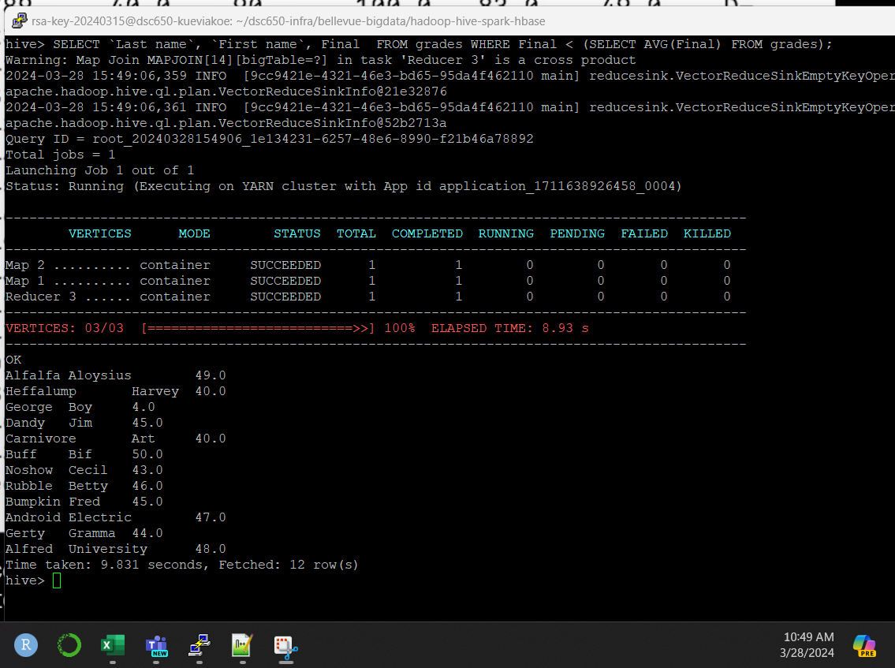

**Query 3: Top 5 students with the highest scores in Test 1**

SELECT `Last name`, `First name`, Test1 FROM grades ORDER BY Test1 DESC LIMIT 5;

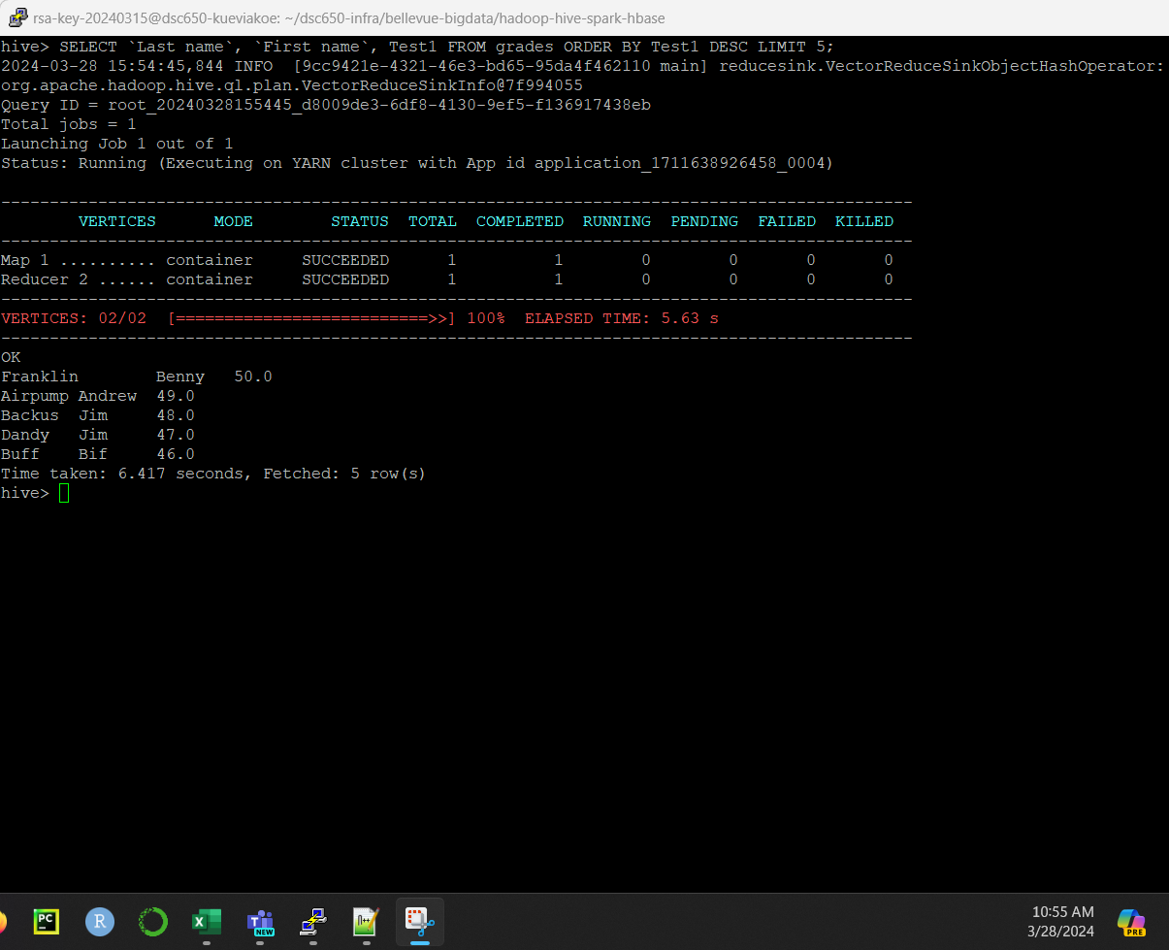

For the assignment, I am choosing the world population data. The data can be found on Kaggle, at <https://www.kaggle.com/datasets/sazidthe1/world-population-data>

I chose the world population dataset because it has information about population dynamics over time, including data from 1970 and 2023, along with details about country’s areas and continents.

This dataset will allow us to compare demographics, analyze population density, and track the evolution of populations across different continents.

**Query 1: 10 most populated countries in 2023**

*SELECT Country, Continent, Population_2023 FROM world_pop_data ORDER BY Population_2023 DESC LIMIT 10;*

**Query 2: Percentage of population growth between 1970 and 2023**

*SELECT Continent, SUM(Population_1970) AS Total_Pop_1970, SUM(Population_2023) AS Total_Pop_2023,*

*(SUM(Population_2023) - SUM(Population_1970)) / SUM(Population_1970) * 100 AS Percentage_growth*

*FROM world_pop_data*

*GROUP BY Continent*

*ORDER BY Percentage_growth ASC;*

**Query 3: Size of each continent**

*SELECT Continent, SUM(Area_km2) as Total_Area_Km2 FROM World_pop_data GROUP BY Continent;*

Query 4: What are the top 5 countries with highest density in 2023

SELECT Country, Continent, Population_2023/Area_km2 as Density FROM World_pop_data ORDER BY Density DESC LIMIT 5;

**Query 5: Continents’ density in 1970 and 2023**

*SELECT Continent,*

*SUM(Population_1970)/SUM(Area_km2) AS Density_1970,*

*SUM(Population_2023)/SUM(Area_km2) AS Density_2023*

*FROM world_pop_data*

*GROUP BY Continent;*

